**Leader Overview**



**Volume Overview**

**How do I live for God?**

*As we learn how to live for God, we’ll explore what that looks like in our everyday life. We know the Bible speaks to us, and God wants each of us to live connected to other believers. So, since that’s all true, how do we put God first? How do we get through all the confusion and uncertainty in this world? What does God expect when it comes to giving? How can we show others we care? In these sessions, we’ll consider what the Bible has to say in response to very important questions like these*.

**Session Overview**

**I Pursue God**

*As we desire to live for God, our priority is to pursue a personal relationship with Him. One of the ways we can pursue God is by talking to Him. We can talk to Him about every aspect of our life. In our Bible story today, Jesus gave us a simple model to follow when we pray, the Lord’s Prayer*.

**Bible Lesson**

The Lord’s Prayer

[Matthew 6:5–18](https://ref.ly/logosref/Bible.Mt6.5-18)

**Faith Fact**

I can talk to God.

**Faith Verse**

[Matthew 6:33](https://ref.ly/logosref/Bible.Mt6.33) (NLT)

“Seek the Kingdom of God above all else, and live righteously, and he will give you everything you need.”

**Preparing for the Session**

**Leader Preparation Time: 20–25 Minutes**

|  |
| --- |
| ***You Will Need***  ***Large Group***   * *Bible* * *Worship songs (Song suggestions: “Chain Reaction” by River Valley Worship; “Only Wanna Sing” by Hillsong Young & Free; “Build My Life” by Passion; “Way Maker” by Leeland)* * *For groups not using a phone or tablet only, add:*   *• Projector or TV*  *• Laptop*  *•* ***Countdown60 Video****– 60 seconds*  *•* ***Faith Fact Slide***  *•* ***Faith Verse Video*** *or* ***Slide***  *•* ***Bible Lesson Video***  *•* ***Teaching Point Slides 1–3***  *•* ***Lord’s Prayer Slide***  *• White board marker*  *• Toy crown*  *• Toy badge*  *• Hat*  *• Keys*  ***Small Group***  *•* ***Small Group Group Connection Page****, one per kid*  *• Pencils or pens, one per kid*  *• Bibles for kids in the group to share*  *• White board*  *• White board marker*  *•* ***Small Group Activity Page****, one per kid*  *• Pencils or pens, one per kid*  *• Crayons*  *To access session content and videos from a computer, visit:* [*BibleEngagementProject.com/downloads*](https://bibleengagementproject.com/downloads) |
| ***Getting Ready***  ***Large Group***  *• Download videos and slides if needed.*  *• Select worship song(s) and have them ready to play.*  *• Read the Bible Lesson Scripture to prepare for teaching time.*  ***Small Group***  *• Print copies of the* ***Small Group Group Connection Page****, one per kid.*  *• Print copies of the* ***Small Group Activity Page****, one per kid.*  *First time leading* Learn *for Kids? Check out the* [*Facilitator Guide*](https://0b769b0ed3569ef9d18b-f88d8272f61086866d50d048b43ef630.ssl.cf2.rackcdn.com/sites/biblengagementproject/Listen_Facilitator_Guide.pdf)*.* |

**Large Group**

**30 Minutes**

*See what’s needed at the beginning of the session.*

**Introduction**

Welcome! I’m glad you’re here! How many of you have someone in your life that you talk to pretty much every day? *(Group response)* Who are they? *(Allow responses.)* That’s awesome! We talk often to people we love who are important to us. We also talk with people who have something valuable for us to hear from them, such as our teachers.

**Faith Fact**

Today, we’ll learn that we can talk to God, the Creator of the universe. Pretty crazy right? Our Faith Fact for today is **I can talk to God**.

• *Show the* ***Faith Fact Slide***.

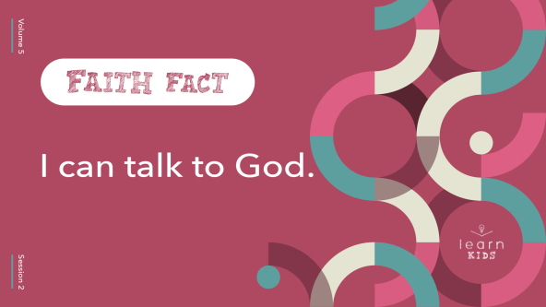

Let’s say it all together. **I can talk to God**. Now choose a fun way to say it. Loud, quiet, with an accent, in a silly voice. Say it one more time. **I can talk to God**. Great job!

**Game**

**Telephone**

How many of you have ever talked on the phone, and it was hard to understand the person you were talking to? *(Group response)* Maybe they had a lot of background noise or were out of signal range. Maybe they just weren’t speaking loudly or clearly enough. It can be easy to misunderstand someone when we don’t hear them clearly.

Today, we’ll play a classic game of Telephone that can give us some pretty silly results. I’m going to whisper something silly in one person’s ear. They’ll pass what I said on to the next person and so on. You must whisper quietly so that no one else can hear. Let’s see how my message travels.

• *Share one of the phrases below with the first person. Continue until all the kids have heard it*.

• *Play as many rounds as you like*.

• *Some phrases to get started:*

• Two tiny toads ate fat flying flies.

• The funny bunny hid the colored candy in the colored can.

• The queen sat on her throne and ate sour candy.

• Many monkeys jumped in the giant bounce house.

• Dogs dig holes for big bones.

• A bunch of yellow bananas launched on a blue boat.

• Twelve tumbling people pulled turnips.

**Worship**

Wow, great job! Isn’t it crazy how much a phrase can change from person to person? It would have been much better and easier to understand the original phrase if I had told everyone at the same time, right? *(Group response)* When we talk to God, we don’t need to pass our messages through anyone else. Thankfully, we can talk directly with Him. Let’s start by worshipping Him together by singing.

• *Lead the kids in singing one or two praise songs. See suggestions at the beginning of the session*.

**Bible Lesson**

One of my favorite things is to listen to you sing and worship God. You did a great job today. Now, it’s time to learn from God’s Word. Today, we’ll read about Jesus teaching us about talking to God. What’s another name for that? *(Allow responses.)* Let’s talk to God now as we bow our heads and pray together.

**Prayer**

|  |
| --- |
| *Dear God, please help us learn from Your Word today. Help us to see how we can talk with You and how that can help us stay close to You. Amen.* |

**Video Intro**

Just before we look at the Bible story, let’s watch this video.

• *Play* ***Bible Lesson Video***.

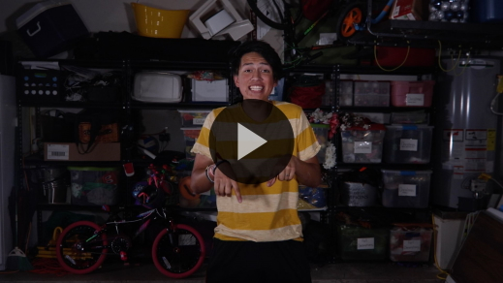

**Bible Story**

**The Lord’s Prayer**

Earlier we talked about how we talk to those we are close to. What kinds of things do you talk about with the people closest to you? *(Allow responses.)* In the Bible story, Jesus was teaching His followers about talking with God. If you want to follow along, open your Bible to [Matthew 6:5–18](https://ref.ly/logosref/Bible.Mt6.5-18).

• *Read the Bible story aloud to the group*.

• *In order to keep Large Group time moving along, we don’t recommend having the kids read*.

• *Optional: Remind the kids to mark this place with their Bible Bookmark so they can read it on their own at home*.

**Teaching Time**

|  |
| --- |
| ***You Will Need***   * ***Teaching Slides 1–3*** * *White board marker* * *Items to represent people in different roles (toy crown, toy badge, hat, keys, etc.)*   *No prep needed for this activity.* |

How many of you have ever thought about how you should pray? *(Group response)* Well, the Bible can help with that. It contains some of the things Jesus said when He taught people how to pray. He even told them what kinds of things to pray about when they talked to God.

When are times that you might normally pray? *(Allow responses.)* Those are great answers. We can pray anytime and anywhere. Jesus wanted His followers to know that they could talk to God through prayer. Remember today’s Faith Fact? **I can talk to God**. Let’s say that together one more time. **I can talk to God**. No matter where we are, we can talk to God. That’s incredible! Let’s find out more.

**1. Relationships need conversation**.

• *Show the* ***Teaching Point 1 Slide***.

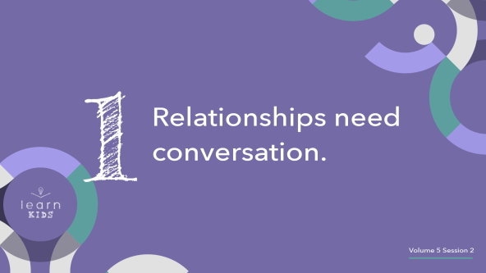

Raise your hand if you have a best friend that you’ve never talked to. Written words like texting count as talking for this, too. *(Group response)* I can’t imagine how two people could be best friends without being able to communicate with each other. Someone you barely know at school probably isn’t your closest friend because they don’t know all the things about you, such as the games you play or the things you like.

How often do you talk to your best friend? *(Allow responses.)* Exactly! We connect with those closest to us often, sometimes many times a day. If you never talked to your best friend, you wouldn’t be able to get close to them. If all of a sudden, you stopped talking to your best friend, I think you’d end up drifting apart over time.

The same is true with our connection to God. If we never talk to God in prayer, then we can’t really get close with Him. If we were close at one point but stopped talking to Him, then we’ll end up feeling far apart from God. Talking to God is an important way we build a relationship with Him. We build a stronger connection as we have conversations in prayer.

**2. We talk to God like a loving father**.

• *Show the* ***Teaching Point 2 Slide***.

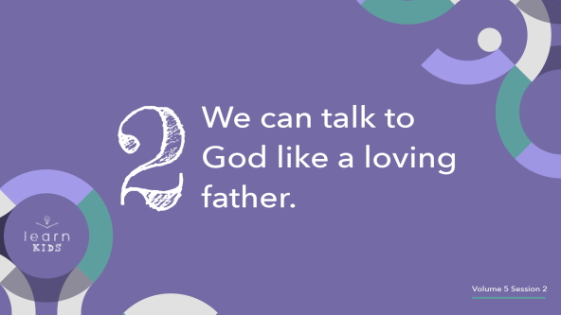

Let’s think about how we talk to different people. We’ve already talked about how we talk to our friends. We may talk differently to people in authority, such as teachers *(hold up white board marker)*, police officers *(hold up toy badge)*, and adults in general *(hold up a hat or set of keys)*.

Imagine a soldier, who is about to go on a special mission, walking up to the president of our country and saying, “What’s up man? What’s the low down on my next mission, dude?” Would that be okay? *(Group response)* Not at all! What would the soldier most likely say? *(Allow responses.)* I could see him saluting and saying, “Sir, it’s an honor to serve.”

We might be tempted to talk to God like the all-powerful One He is. Did you notice what Jesus said we should call God? *(Group response)* Jesus said we should say, “Our Father.” We should talk to God like we’d talk to our dad or another family member we’re close to. God wants us to talk to Him like He’s a loving father because that’s exactly who He is—our Heavenly Father.

Of course, we still respect and honor God. He knows everything about us and loves us more than we could ever know. Because of that, we can be open and honest with Him, trusting that He will help us work through whatever we need.

**3. We can talk to God about anything**.

• *Show the* ***Teaching Point 3 Slide***.

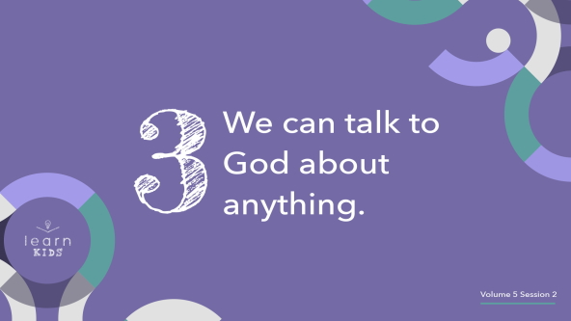

Do any of you have a friend who you only talk with about one thing? Maybe you and your friend only talk about sports, movies, video games, clothes, or something else. Some friendships are like that. If you only ever talk about one thing with someone, then you don’t really get to know them very well. They don’t get to hear the other things you care about either.

In a similar way, God wants you to talk to Him about more than just one thing. Sometimes we think God only wants to hear us say we’re sorry for doing wrong things, but that’s just not true. He cares about every part of us, so we can talk to God about our mistakes, our hopes and dreams, the things we need His help with, and anything else. We can sit quietly with God, too. He is ready to talk with us. He wants us to seek Him, to pray to Him, and to share our heart with Him.

I love that Jesus modeled this for us in the Lord’s Prayer. He’s showing us we can talk to God about anything and everything. We can thank God for what He’s done for us. We can ask Him to provide for our daily needs. We can share anything and everything with Him. The best part is that He *wants* us to talk to Him about all of those things. Jesus told us so.

**Prayer and Response**

*Consider playing a worship song softly in the background while kids pray*.

• *Show the* ***Lord’s Prayer Slide***.

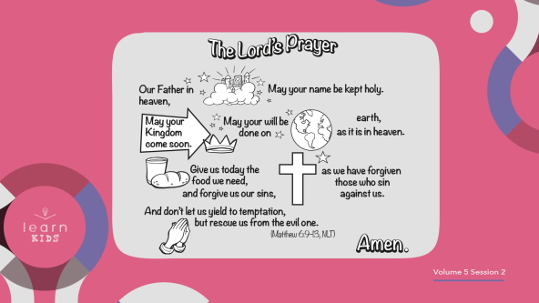

Let’s take some time to say the prayer Jesus taught. Maybe you pray a lot, and maybe you’ve never prayed before. No matter which describes you, all of us can learn more about prayer. Today, let’s pray the Lord’s Prayer.

**Prayer**

• *Lead kids in praying the Lord’s Prayer*.

• *Optional: Have the kids repeat phrases of the prayer after you*.

|  |
| --- |
| *Our Father in heaven, may your name be kept holy.*  *May your Kingdom come soon.*  *May your will be done on earth, as it is in heaven.*  *Give us today the food we need,*  *and forgive us our sins, as we have forgiven those who sin against us.*  *And don’t let us yield to temptation, but rescue us from the evil one.*  *Amen.* |

Now let’s respond to what we’ve learned today. Choose one thing from the Lord’s Prayer to talk to God about. It could be how great God is or asking Him to help you follow Him. Maybe you need God’s help with something or His forgiveness for something. We’ll take a minute or two to practice talking with God.

• *Pause while kids pray. Then, close in prayer*.

|  |
| --- |
| *God, thank You for listening to us. We love You. Amen.* |

That was wonderful to talk with God. Always remember our Faith Fact. **I can talk to God**. No matter what’s on your mind, God is ready to listen.

**Faith Verse**

Our Faith Verse reminds us that seeking God should be a priority for us.

• *Play* ***Faith Verse Video***.

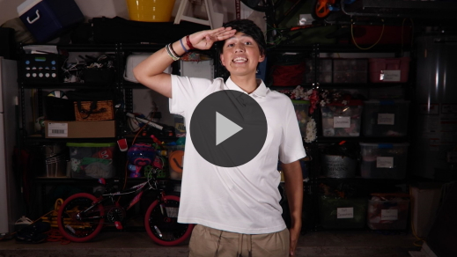

[Matthew 6:33](https://ref.ly/logosref/Bible.Mt6.33) (NLT)

“Seek the Kingdom of God above all else, and live righteously, and he will give you everything you need.”

This verse has a wonderful promise for us. When we seek to put God first, He will take care of everything else we need.

**Faith Fact**

One of those ways we can seek God is by praying and listening to God. Remember our Faith Fact for today?

• *Show the* ***Faith Fact Slide***.



Say it with me. **I can talk to God**. I know you can do it. It’s been great learning with you today.

• *Dismiss kids to Small Group time or to go home if your group time ends here*.

**Small Group**

**30 Minutes**

*This section can be done in conjunction with the large group or on its own if you do small groups with your kids. During Small Group time, the goal is to connect the kids with the Word of God and to each other. All activities are led by the small group leader.*

**Group Connection**

**Paper Prayer Planes**

|  |
| --- |
| ***You Will Need***   * ***Small Group Group Connection Page****, one per kid* * *Pencils or pens, one per kid* * ***Countdown60 Video****– 60 seconds*   ***Getting Ready***   * *Print copies of the* ***Small Group Group Connection Page****, one per kid.* |

Something amazing about prayer is that we can ask others to pray with us. Let’s take some time to think about something that we could ask someone to pray about with us. What are some things we could pray for? *(Allow responses.)*

• *Give everyone a copy of the* ***Small Group Group Connection Page*** *and a pen or pencil*.

Think about something you’d like another person to pray about for you. Then, write it down on your paper. Don’t put your name on the prayer request.

• *Wait until all kids have written requests*.

All right! Now that we have our prayer requests written, let’s follow the directions and fold your piece of paper into an airplane.

• *Help kids fold their planes if needed*.

Let’s have some fun. We’ll have an airplane throwing party for one minute. Spread out and then fly your plane. Then, pick up someone else’s plane that lands near you and fly that one somewhere. When the timer reaches 0, grab the paper airplane closest to you and bring it to me. We’re going to use the planes to pray for each other during prayer time.

• *Play the* ***Countdown60 Video****–60 seconds*.

• *Collect the prayer requests when you are done playing. These do not go home with the kids at the end of the day*.



**Learn about It**

|  |
| --- |
| ***You Will Need***   * *Bibles for kids in your group to share*   *No prep needed for this activity.* |

**Scripture Search:** [**1 Thessalonians 5:16–18**](https://ref.ly/logosref/Bible.1Th5.16-18)**;** [**Matthew 6:5–8**](https://ref.ly/logosref/Bible.Mt6.5-8)**;** [**Luke 18:9–14**](https://ref.ly/logosref/Bible.Lk18.9-14)**;** [**James 5:14–16**](https://ref.ly/logosref/Bible.Jas5.14-16)

Let’s dig deeper into God’s Word and see what else He has to say about prayer. As we find and read each of these verses, let’s consider: What does this Scripture mean for our life today?

• *Give each kid a Bible and search for one or more of the Scriptures as a group together (as time allows). When everyone has found the Scripture, have one of the kids read it. Then, answer the questions about it*.

• *Pair kids who need additional help with older kids or start simple and look up the session’s Bible story Scripture:* [*Matthew 6:5–18*](https://ref.ly/logosref/Bible.Mt6.5-18)*. Kids will get better finding Scriptures the more they practice*.

• *Optional: Make this a competition to see who can find the Scripture first*.

**Bible Reading Tip**

God’s Word is so good and can teach us so much about prayer. One thing that can help you learn more about what God has to say is by highlighting your Bible. You might be nervous about writing in a book, especially God’s Word, so ask your parents first. This is something lots of people do to help them read the Bible and remember special passages. You can highlight verses that you like or that stand out to you. This will help you find them more easily if you ever go looking for them.

Did you know that you can even highlight Bible verses on apps on your phone or tablet? As you look for verses to highlight, it can help you focus on the words and understand what they truly mean.

**Challenge**

This week, find the Lord’s Prayer in your Bible and highlight it. Then, try to memorize it by praying it regularly. Your ***Activity Page*** will tell you where to find it.

**Faith Fact**

Reading and talking about prayer reminds me of our Faith Fact. Say it with me. **I can talk to God**.

**Group Discussion**

*Feel free to use all or just a few questions as a jumping-off place for good discussion. Questions marked with * are designed for more conversation. Adjust the questions based on the age or maturity of your group. Typically, older kids will be able to dive a little deeper than younger ones*.

**Questions**

• *If small group activities are not immediately following large group time, you may want to read the Bible story passage before this discussion*.

* What comes to your mind first when you hear the word *pray*?

What relationship did Jesus compare our relationship with God to?

* Why do relationships need conversation?

What kinds of things did Jesus say to pray for in the Lord’s Prayer?

* What other kinds of things can we talk to God about?

* When is a good time for you to talk to God, and why?

**Prayer Requests**

*Finish group discussion by sharing prayer requests and praise reports. Keep track of your small group’s prayer requests and review them each time you meet*.

Earlier you wrote out prayer requests and then we had some fun with them. I’m going to give each of you someone’s request to pray for.

• *Give each kid one of the prayer requests*.

**Prayer**

*Have kids pray for each other’s prayer requests*.

**Faith Verse Review**

|  |
| --- |
| ***You Will Need***   * *White board* * *White board marker*   *No prep needed for this activity.* |

Our Faith Verse for today is [Matthew 6:33](https://ref.ly/logosref/Bible.Mt6.33). It tells us that when we seek God’s kingdom and honor God’s ways, He takes care of us. Let’s watch the Faith Verse video and do the actions together.

• *Show* ***Faith Verse Video***.



[Matthew 6:33](https://ref.ly/logosref/Bible.Mt6.33) (NLT)

“Seek the Kingdom of God above all else, and live righteously, and he will give you everything you need.”

**Faith Verse Fun**

**Word Wipeout**

This verse is one of the most important verses in the whole Bible, so we’ll try to keep it in our mind and heart through this game. I’ll write the verse on the board.

• *Write the Faith Verse large enough for everyone to see*.

Now, let’s read it together one time to keep it fresh in our mind. Pay attention because we’re about to challenge our memory.

• *Read the verse together*.

Now, we will take turns erasing words and replacing them with lines before repeating the verse. Let’s see if we can keep saying the verse as the words disappear.

• *Each time the group recites the verse, have a volunteer come up and erase one word from the verse. Then, recite the verse again*.

• *Repeat until the whole verse is gone*.

• *If you’re short on time, consider erasing multiple words at a time or whole phrases*.

Great job, everyone! We’re learning our Faith Verse. I hope none of us ever forgets it.

**Activity Page**

**The Lord’s Prayer**

|  |
| --- |
| ***You Will Need***  *•* ***Small Group Activity Page****, one per kid*  *• Pencils or pens, one per kid*  *• Crayons*  ***Getting Ready***  *• Print copies of the* ***Small Group Activity Page****, one per kid.* |

In our Bible story, we learned about a time Jesus taught His disciples how to pray. This is known as the Lord’s Prayer, but some words are missing on your page. Check it out.

• *Give each kid a copy of the* ***Small Group Activity Page*** *and a pencil. Then let them complete it*.

Fill in the missing words from the Lord’s Prayer. Then, color the pictures.

**Dismissal**

We learned a lot about prayer today. Don’t forget the challenge to learn the prayer that Jesus taught. God wants us to talk to Him and He wants to talk with us. Let’s close by talking to God now.

**Prayer**

|  |
| --- |
| *Dear God, thank You for making a way for us to talk to You with prayer. Please help us to love talking with You every day. Help us to hear Your voice and to stay connected with You. Amen.* |

**Faith Fact Recap**

• *Show the* ***Faith Fact Slide***.



Something I want you to remember from today is our Faith Fact. Say it with me. **I can talk to God**. I’m glad you came today. I can’t wait to see you next time.

• *Send home the* ***Small Group Activity Page***.

• *Remind parents that there are* ***Family Devotions*** *available on the app to do with their kid*.

• *Tell everyone the date and time for the next session*.